

***LAB REPORT 7***

***Muhammad Rafay***

***20P-0018***

***Computer Networks***

***Sec A***

***About :***

This lab is about experiencing to configure FTP on a generic server and transferring files between client and sever.

**TASk1.**

**Topology.**

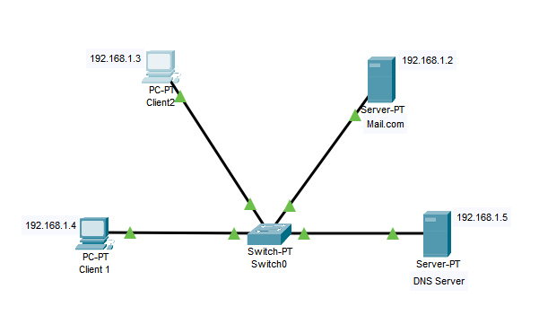

**Client 1 Inbox.**

**Mail received from Client 2.**

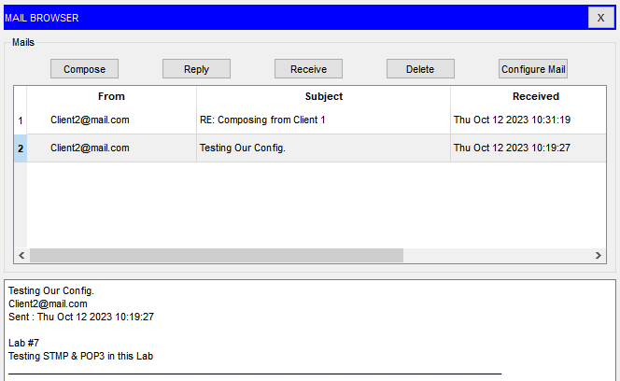

**Reply received from Client 2.**

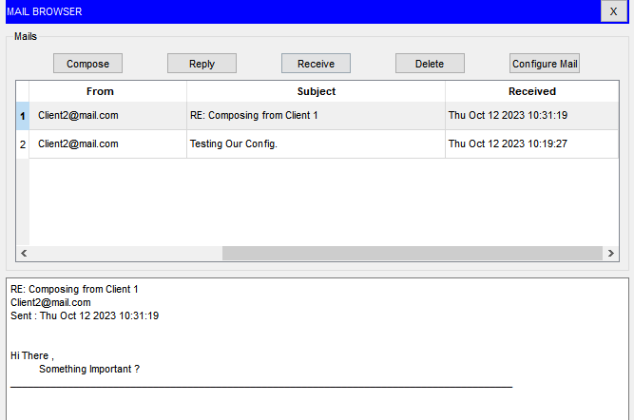

**Client 2 Inbox.**

**Mail received from Client 1.**

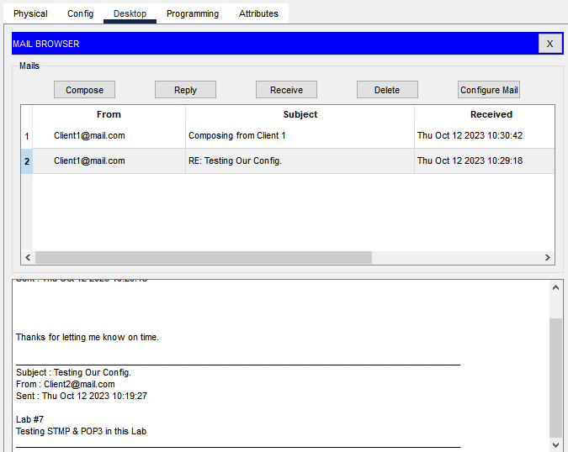

**Reply received from Client 1.**



**Task 2.**

**Topology.**

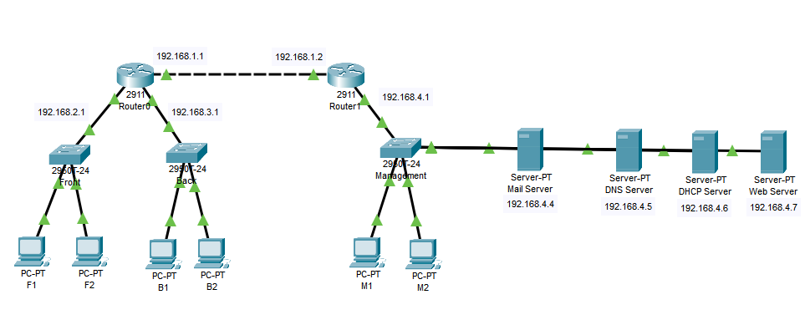

**Router 0 Static Config.**

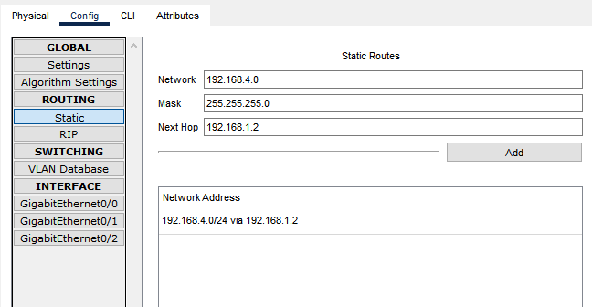

**Router 1 Static Config.**

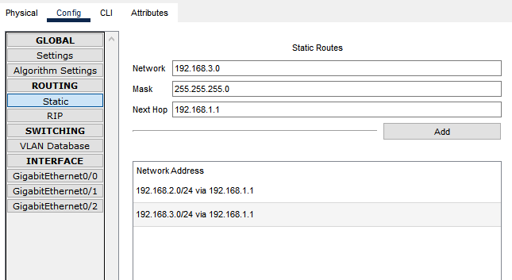

**Configuring Servers.**

**Mail Server**

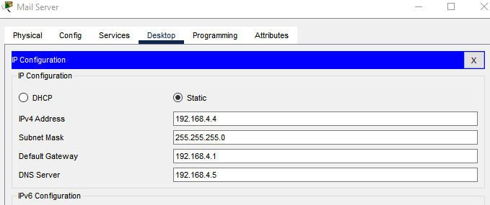

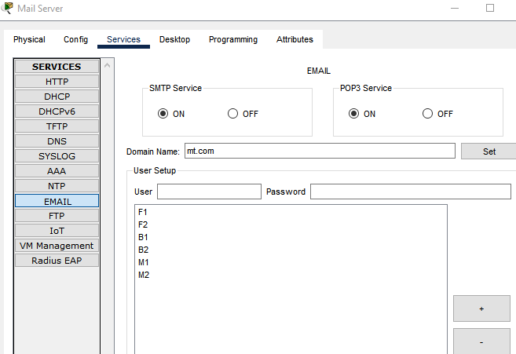

**DNS Server**

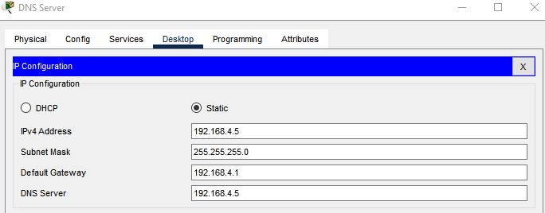

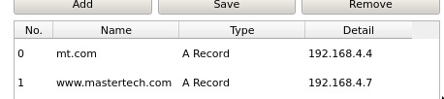

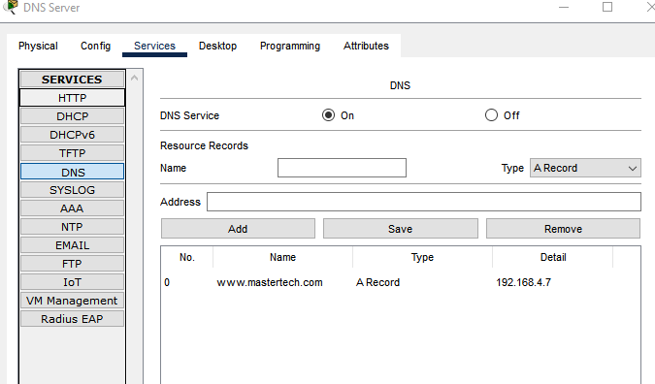

**DHCP Server**

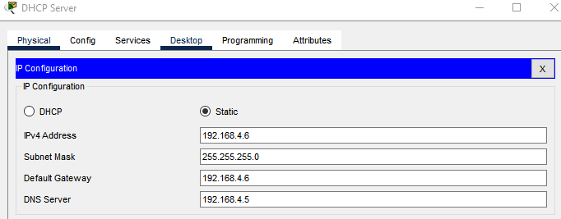

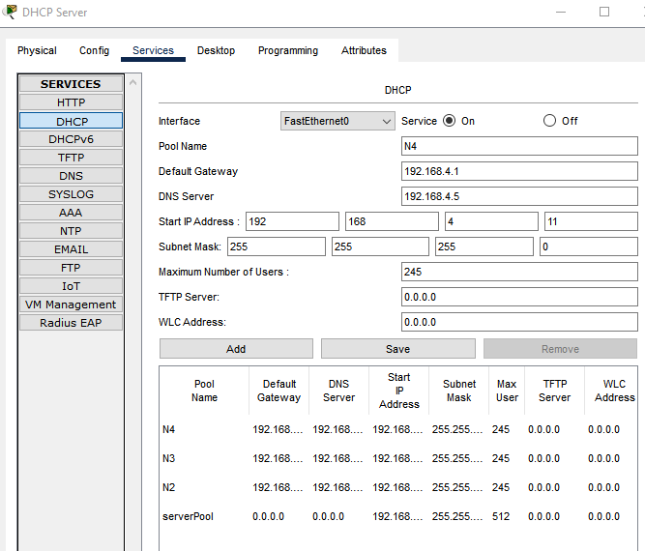

CLI Router Setting for ip Helper-address

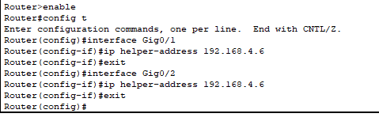

**Web Server.**

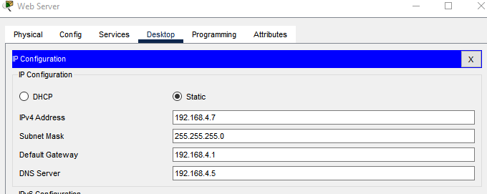

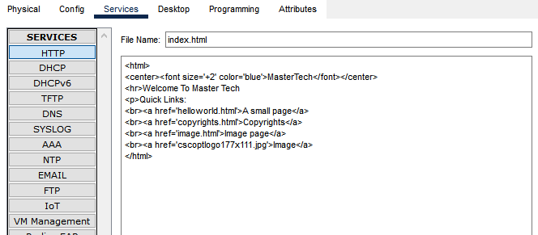

**Assigning Emails and Logging in to our PCs**

**Frontend Dep.**

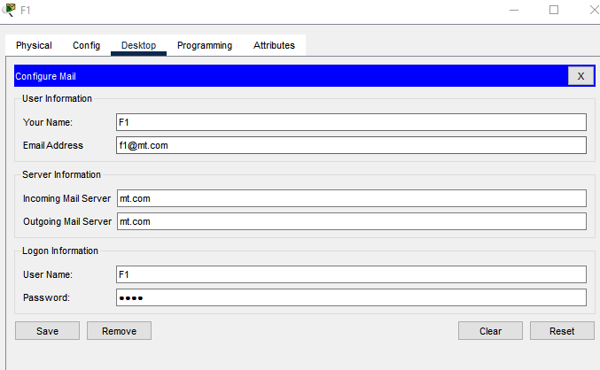

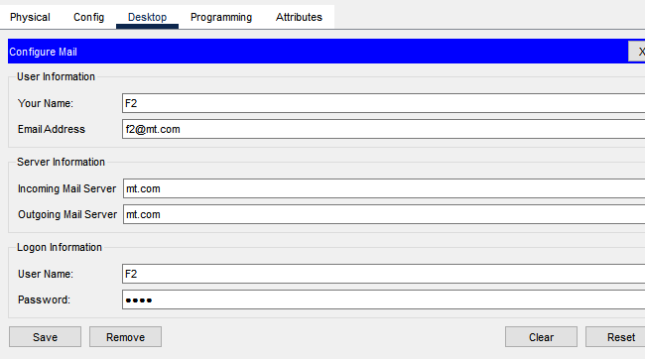

Same goes for the PCs in other departments i.e. back end and management deparatment .

Assigning IPs to our server using DHCP.

Network 2.0

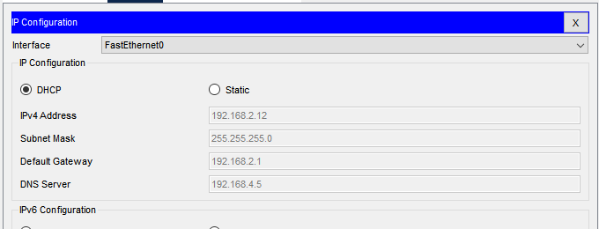

Network 3.0

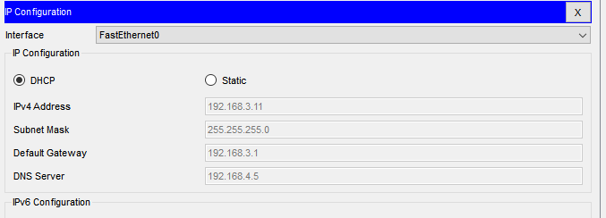

Network 4.0

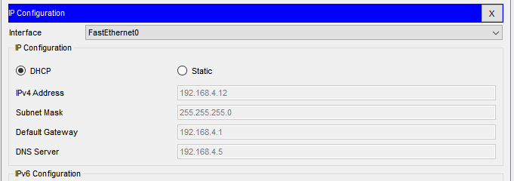

**Accessing our Website using one of our PC**

Frontend PC

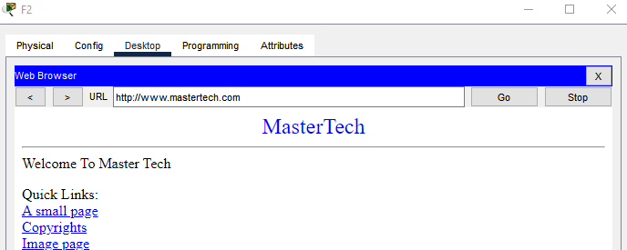

Backend PC

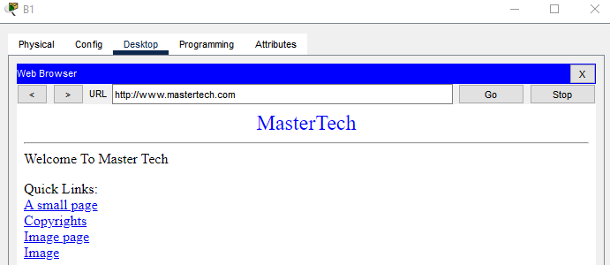

Management PC

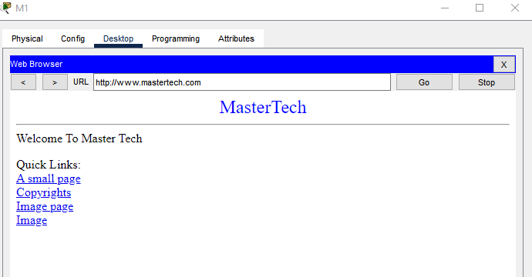

**Testing our mail protocols by sending and replying to some mails.**

